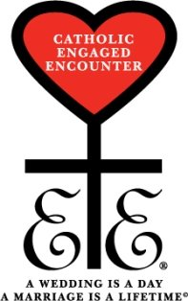
Joliet CEE Community Meeting
Saturday, October 6, 2012

Opening Prayer

Unit Update

Financial Update

New Weekend Cost

Banners

Weekend Supplies

Weekend Setup

Recruitment

2014 Convention

Coordinators

Hotel

Speakers

Items for the good of the whole

Prayer Requests

Closing Prayer

Upcoming Dates
December 8 – Christmas Party at Gilberts

